SEXUALLY TRANSMITTED DISEASES (S.T.Ds.)

What are S.T.Ds.?

SEXU 60

SEXU 21

These are diseases that are spread through sexual contact from an infected sexual partner. In the 1950s through 1960s there were approximately five sexually transmitted diseases (STDs) that we had to be concerned about. Now there are over fifty. Many of these STDs including AIDS, are for life, incurable, and bring devastating consequences such as infertility, for life. STDs are not uncommon today. Many, many people are walking around with STDs that they either know about, or are unknown to the infected person because they are not yet showing symptoms of these diseases.

Result of Moral Breakdown in our Nations

STAT 22
Some time ago, the World Health organization reported that STDs were the most frequently reported transmittable diseases worldwide. Eighty-seven percent of the world’s transmittable diseases are spread sexually, leaving only thirteen percent that are communicable in other ways. Many of the world’s diseases are behaviour related and preventable! Our nations do not have to be as sick as they are. This is where God’s Church can come with answers and solutions to equip people not to fall prey to sickness over which they have a choice.

STDs and Infertility

SEXU 61
Infertility (women unable to bear children) is on an unprecedented rise as never before. Much of this is a result of women contracting a sexually transmitted disease (STD) which has left them without the ability to bear children. Many are unaware that they have such a disease and experience much distress over not being able to fall pregnant.

There is a myth (mistaken idea) in some countries that if a woman cannot bear a child, then she alone is the cause. This has been proven to be medically false. In many cases of infertility, the cause is actually a problem in the man’s body. Worldwide, physicians are finding that the sperm count in men is less than ever before. Men are increasingly unable to impregnate women, many times because of STDs that they have contracted at some time. In some cultures, if a woman shows an inability to bear a child within a reasonable amount of time, the husband will chase her away and take another wife. This is based on the mistaken idea that women only are the cause of infertility. This is not so. The cause of infertility in a couple could be caused by a medical problem in either the man or the woman, or both. Proper medical examinations are the ONLY way a couple can find out the cause for inability to bear a child. Many times the medical barrier causing infertility can be corrected if treated, and the couple will be able to have children. Sometimes, however, the cause of infertility (whether caused by the man’s body or the woman’s body) cannot be corrected and the couple needs to be advised to seek other options for family fulfillment. Some of these can be adoption and involvement in caring for the many street children/orphans needing homes, etc.

SEXU 62

Infertility is NOT always caused by STDs. There can be other causes of infertility. However, a main cause of infertility and premature death in babies and parents is because of sexually transmitted diseases (STDs). What a different, healthy world we would have if people would change their sexual behaviour! What a better place it would be for our children and our grandchildren.

STDs and Cures

Some STDs such as Syphilis, are often curable and leave no problems in the body if they are caught and medically treated early in the progression of the disease. Although there are cures for some STDs, cures have not eliminated the problem! For example: although there is a cure for Syphilis (STD) the world is now experiencing a 40-year-high incidence in the spread of Syphilis. Many STDs at present have no medical cure. Once you are infected (such as with HIV resulting in AIDS) you are infected for life. The result of STDs is often a poor quality of life because of illness and premature death.

PREVENTION OF SEXUALLY TRANSMITTED DISEASES

“If the Son therefore shall make you free, you shall be free indeed” (John 8:36).

God created each individual with the ability to have control over his/her sexual actions. Freedom to choose means one is neither under compulsion nor under restraint. The freedom God gives each individual also includes the freedom to say NO to sex.

Sexual Freedom

SEXU 63

In our present-day world, sexual freedom is misinterpreted to mean = having sex without restraint whenever you want it, with whomever you want it, however you want it. Freedom is not without boundaries. Freedom is choices about friends, what to wear, career, leisure activities, and to have sex or not to have sex, etc.

True Freedom Requires Responsibility

SEXU 64
- To God
- To one’s self
- To family
- To the community
- To my country

Sexual freedom implies the ability to balance and integrate one’s sexual urges in a manner that is best for oneself and everyone around by the following:

- By my present marital status: Am I single and developing my character at this time of my life in preparation for the time when I will be married? Am I
respecting my body by not subjecting it to the consequences of premarital sex like STDs, AIDS, hurt emotions, “using” other people for my own sexual gratification? Do I take control over my sexual urges and refrain from having sex knowing I CAN and WILL WAIT for sex in marriage only?
- Am I married and committed to my spouse by being sexually trustworthy, not risking STDs in myself and my spouse by having girlfriends or boyfriends? Am I a good role model to my children in my sexuality by being faithful to my spouse?
- How balanced is my conscious sexual activity with the rest of my life? Am I preoccupied with sexual matters and urges? Am I sexually addicted? Do I ignore my sexual urges and pretend I don’t have any? Does it occupy me too much? Or too little? What goes on in my mind regarding sexual things?

Sex outside of marriage is not godly and is unhealthy. Ignoring sexuality and suppressing it is equally unhealthy. However, it should be noted that finding oneself in an unmarried status is NORMAL and self-control in the sexual areas of one’s life while unmarried, is different from sexual suppression. Unmarried persons (not having found the right person to marry, widowed, or choosing to be single such as is thought of the apostle Paul in the New Testament) need to channel and balance sexuality urges within the boundaries of God’s Word, the Bible. Sex in marriage ONLY, is healthy whatever one’s marital status in life.

FACT 56

Animals are “urge” orientated; God made people to be “relationship” orientated. Animals have sex without any relationship involved. God made people to have sex within marriage where “relationship” is the primary focus, not just sex.

FACT 57

God’s Sexual Freedom for Mankind
- Freedom to see one’s sexuality as a gift from God having unlimited value. One’s private parts are a special gift from God. They are not dirty or nasty or tools to use for personal gratification
- Freedom to see another’s sexuality also as a gift from God having unlimited value
- Freedom to withstand constant sexual stimulation from the media and society (radio, TV, magazines, internet, etc.) and channel energy in non-sexual ways
- Free in mind, emotions, and actions to be all that God has created me to be
- Freedom to be masculine or feminine (depending on your birth gender) and to find the best way to express your gender
- Freedom to make mature human decisions, not acting out of pressure or force from others who will try to make them for you
- Freedom to express genuine love, respect, human emotions and values in sexual ways, ONLY within the boundaries of married fidelity and relationship
- Freedom to express genuine love, respect, human emotions, and values in non-sexual ways in relationships

Factors Which Influence Sexual Activity of People

- Family – basic family unit in which values and attitudes regarding sexuality are nurtured and formulated, e.g. a child who is sexually abused and has a violent/distorted view of sex. A child who sees the father degrade and demand from the mother will often produce children who see sex as an “expectation” rather than an act of love. A child who sees mother manipulate the husband through sex to gain money often sees sex as a “tool” to get what you want…manipulative sex. These are attitudes that are formed in the child as he/she grows up.
- Society/Media – Africa is at present becoming very influenced by the “Western” media through TV. TV programmes are largely shaped by what the public demands and what is deemed “cool.” Unfortunately “sex” sells and that which comes over the media is determined by money and by what sells.
- Mind altering drugs/herbs – alcohol/drugs are often the factor involved in unwanted sexual force, such as rape and incest. These distort one’s ability to make rational sexual decisions. Many a young person has taken alcohol/drugs at a party and come home with more than they bargained for…sexually transmitted disease. Herbs and naturopathic medicines, if used correctly, can be helpful in treating sickness if they are not mixed with practices that go against God’s Word (yoga, transcendental meditation, witchcraft, etc).
- Family break-up – separation, divorce, migration due to work location where a parent is absent from the family for long periods, can affect the sexual mindset of a child growing up and be carried through to adulthood.
- Economics – ability to earn a living can lend to unhealthy sexual behaviour, such has prostitution, sex-for-money, multiple sex partners, etc.
- Violence/unrest/conflict – can result in a person being angry at other people or at society. This can result in unhealthy sexual behaviour.
- Perceived role of women in society (e.g. that women are the property of men; that women are sexual playthings of men; that women are powerless; women have no brains and are only baby machines; that women have no choice over their own sexuality because they are owned by their husbands; therefore, they have no choice about sex in marriage or infidelity in marriage; that women like forced sex, etc.) All of these wrong and ungodly perceptions can shape wrong sexual behaviour in a child when he/she is grown-up.
- Peer pressure – (what others are doing that gains acceptance) can cause individuals to do things sexually just to gain acceptance. Example: school students and young adults these days are being told that if they don’t have sex there is something wrong with them and that they are stupid; that they must prove themselves sexually. This creates wrong thinking about sexual matters.
- Sex is dirty – therefore one cannot discuss sexuality at all. This causes persons to act out of their misinformation and curiosity rather than out of right teaching about their body and feelings.
- Positive input – from parents, elders, the Church, etc. by nurturing adults who provide positive role modeling, brings moral sexual responsibility, family cohesiveness, self-respect, self-worth, respect for women, caring touches that are not suggestive and abusive, right sexual instruction, and a healthy attitude about one’s sexuality.

Sexually Transmitted Diseases – Genital Sores
One of the early warning signs of some STDs are sores on the penis of a man, and on the vagina or private part area of a woman. Some of the sores that accompany STDs are:
- One or more sores on male penis or female vagina
- Some sores may be clean or they may discharge pus (leak fluid or blood)
- Some sores may be itchy or feel painful
- In addition to the sores, one having an STD may have swellings in the groin and glands near the private parts.

General Points about All STDs
- There are now more than 50 different types of STDs.
- They live inside the human body and do not survive outside the human body.
- Are usually spread through intimate sexual contact; however, some can be contacted through intimacy that is not full intercourse sex.
- They can be passed from male to female, and from female to male, or through same sex. However, it is easier for a female to contract an STD because of the make-up of her private parts. However, men CAN and DO contract STDs also.

General Symptoms of STDs
Any one of these symptoms CAN mean, but does not necessarily mean, that one has an STD:
- Skin changes including sores, blisters, bumps, and rashes around the private part, genital area
- The need to urinate frequently
- Irritation and/or a burning sensation when one urinates, sometimes with pain during urination
- Genital and private part itching, burning sensation
- Noticeable pelvic pain (in females)
- Discharge from the sex organs
- Unpleasant odor/smell from genitals
- Swollen glands and fever

General Complications from STDs
- The germs may cause mental illness after some time.
- The germs may hide in the body and can be passed on to one’s sexual partner during sexual contact. These germs can sometimes be passed without having full sexual intercourse, skin on skin outside the private parts
- Can damage different organs in the body like the nerves, heart, brain, and may lead to death
- Can cause a man to be infertile, and can cause a woman to not fall pregnant

Three Types of STDs

SEXU 65
- Bacterial STDs – can cause major health problems; however, if detected and
treated early, many can be totally eliminated. Usually these are treated with anti-
biotic medicine.
- Fungal STDs – often found on the private parts, skin area and sometimes in the mouth. These can be cured if treated early.
- Viral STDs – are caused by a virus and are generally the most life threatening. It is important to remember that there are no cures for viruses and, up to the present, there never has been a cure for any virus. Once a virus is acquired in a body, it stays in that body and can cause problems for a lifetime. HIV, that causes AIDS, is one such virus. Some of these are HIV/AIDS, genital warts, cervical cancer and hepatitis.

How STDs Cheat People
In many cases of acquiring an STD, the person who has acquired an STD has no symptoms at all. For this reason, one cannot rely on visual inspection to know if they or their sexual partner may have an STD. Even with no symptoms, the infected person can still pass on the STD to other intimate partners. Often, by the time the person begins to show symptoms of an STD, a great deal of damage has already been done to that person’s body.

SEXU 66

Any individual who contracts a sexually transmitted disease (STD) is MORE SUSCEPTIBLE to the HIV virus entering his/her body and dying of AIDS. All STDs lower the body’s ability to fight diseases, weaken the body functions, particularly in the private parts, and weaken the immune system.

SEXU 10

STDs in Men
The germs may:
- Damage the penis – the penis may be eaten by sores so that even after medicines and treatment, the penis may be deformed
- Damage the man’s balls which make the man infertile (unable to produce children)
- Have sores come and go on his private parts and other parts of the body for the rest of his life, even with medicines
- Cause great difficulty in sexual intercourse, or the man being unable to have sexual intercourse
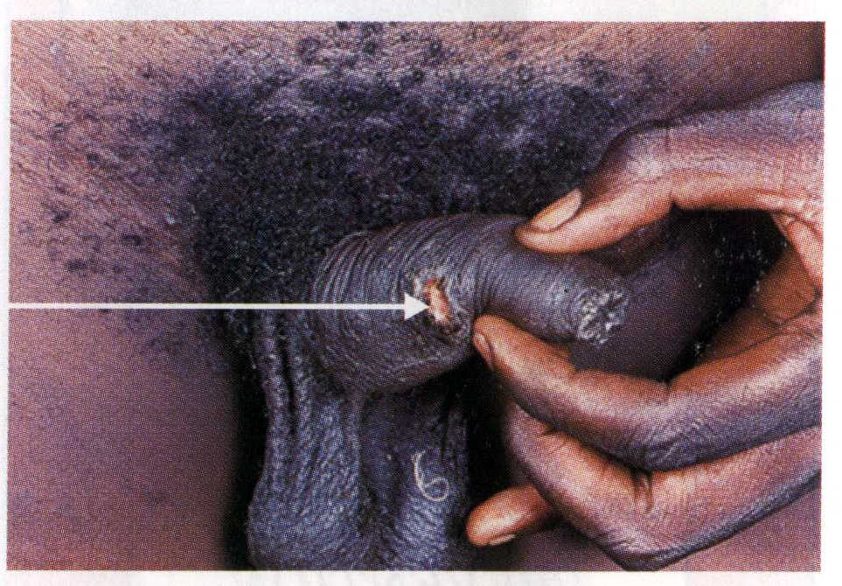

STDs in Women

The germs may:
- Damage the vagina of the woman in her private parts because of sores. The germs can move upward in the woman’s body to her internal organs
- Be passed on to an unborn baby- e.g. many mothers with HIV, syphilis, etc. pass this STD on to their unborn baby
- Cause severe complications in pregnancy in the tubes and other female organs which can be life threatening to a woman and cause death
- Even if treated, some STDs can cause the woman to be unable to bear a child for the rest of her life
- Cause miscarriage, spontaneous abortion of the baby, or death of the baby in the womb before birth
- May cause great difficulty in having sexual intercourse
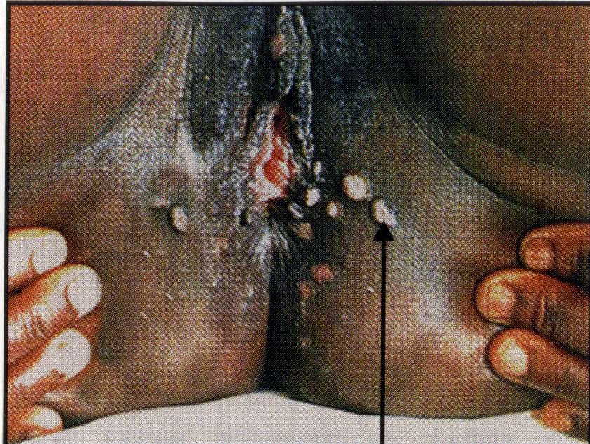

Some Common Sexually Transmitted Diseases (STDs)

The following are STDs which present themselves with sores and/or ulcers:
Syphilis:
- Presents itself with one or more painless genital sores at first
- These sores can go away on their own at first, and come back maybe in months or a year
- Is associated with painless enlarged lymph nodes in the groin area
- Can cause dementia if left untreated
- Many children are born with this STD contracted from the mother

Chancroid:
- Presents itself with one or more painful genital ulcers
- Ulcers may bleed at times
- Is associated with tender enlarged lymph nodes in the groin area
- Sometimes this STD is very resistant and fights against treatment

Herpes:
- Presents itself with small blisters in the genital area
- Is very painful and has NO CURE
- Person infected is infected for life and can pass it on to his/her sexual partner
- Tends to reoccur even with medicines

Lymphogranuloma Venereum:
- Sometimes presents itself with a small genital ulcer
- Is painless
- Presents primarily with enlarged and infected lymph nodes in the groin area – often draining embarrassing pus
- Can be treated

These Are Some STDs Which Present Themselves With Discharges, Fluid and/or Pus:

Gonorrhea:
- Presents itself with yellow-greenish discharge
- Is associated with burning urine and lower abdominal pain in women or painful testis in men
- Can be treated

Trichomonas Vaginalis:
- Presents itself with a frothy greenish discharge and a fishy smell

Candidiasis:
- Presents itself with a thick white discharge
- Is very itchy
- Can be treated

Non-Gonococcal Urethritis:
- Presents itself with yellow/white discharge from private parts
- Is associated with tender enlarged lymph nodes in the groin area
- Can be treated

Other Very Common STDs are:

Human Papaloma Virus (HPV):
- Can cause genital warts, cervical cancer, and other diseases of the private parts

Chlamydia & Pelvic Inflammatory Disease (PID):
- Can go undetected for a long time in the body without symptoms. This
STD often causes infertility by damaging the reproductive organs
causing sterility, problem pregnancies, etc.

Sexually Transmitted Diseases and HIV Infection
It is well documented that the incidence of HIV infection and other sexually transmitted diseases (STDs) is directly related. Many people who have a sexually transmitted disease may not know that they also have HIV as well. At the 1999 ICACA conference in Lusaka, Zambia, it was reported from research done by the Witwatersrand University in South Africa that the correlation between incidences of STDs and HIV is as follows:

SEXU 79
- 1st episode of an STD has a 22% likelihood of HIV infection as well
- 2 to 4 episodes of an STD has a 41% likelihood of HIV infection as well
- 6 to 9 episodes of an STD has a 65% likelihood of HIV infection as well
- 10 or more episodes of an STD has a 79% likelihood of HIV infection as well

How to Avoid Contracting a Sexually Transmitted Disease (STD)
PREVENTION is always better than cure. Individuals DO NOT have to contract an STD, ever! You choose!

SEXU 08
- Exercise control and self-discipline before marriage over your sexual urges
so that you WAIT until marriage for sex. Delay sex for as long as is possible,
to a responsible age for marriage.

SEXU 12
- Keep sex with one man and one woman for life. Multiple sex partners
increase one’s risk of contracting an STD.
- Be faithful and have sex with your marriage spouse only.
- Prior to marriage, both the man and woman should be tested for sexually transmitted diseases (including HIV) to ensure they are not bringing a silent killer into the marriage union.

SEXU 11
- If you already have an STD, use a condom during sex; however, realise condoms do not give 100% safe protection from the spread of these diseases.

What If One is Already Infected with an STD?
ANYONE SUSPECTING THAT HE/SHE IS ALREADY INFECTED WITH AN STD MUST SEEK MEDICAL DIAGNOSIS AND TREATMENT IMMEDIATELY. THE WORST MISTAKE ONE CAN MAKE IS TO DELAY DIAGNOSIS AND TREATMENT OF AN STD OUT OF FEAR AND/OR EMBARRASSMENT. THIS CAN BRING IRREVERSIBLE NEGATIVE CONSEQUENCES THAT CAN EVEN LEAD TO AN EARLY DEATH. DO NOT PLAY WITH STDs. STDs KILL!

SEXU 67
BEHAVIOUR CHANGE IN BOTH MEN AND WOMEN CAN PREVENT
THE INCIDENCE OF SEXUALLY TRANSMITTED DISEASES (STDs)

